

Project Report Template

**1 INTRODUCTION**

* 1. **Overview**

CRM Applications which helps the application to track the No. of jobs he applied and helps him to find the job posted by the various recruiters, find the best attributes to be involved to run the process in a smooth way and easily track.

* 1. **Purpose**

By using this, applicant and the companies easily identified No. of jobs he applied.

**2 Problem Definition & Design Thinking**

**2.1 Empathy Map**

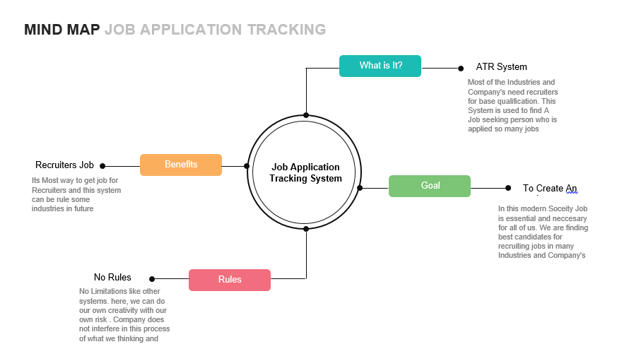

**2.2 Ideation & Brainstorming Map**



**3 RESULT**

**3.1 Data Model:**

|  |  |
| --- | --- |
| **Object name** | **Fields in the Object** |
|  |  |
| Candidate | Field label Data type  Text User |
| Job | Field label Data type  Job title Profile |

**3.2 Activity & Screenshot**

Attach the screenshots of your project activity along with the description.

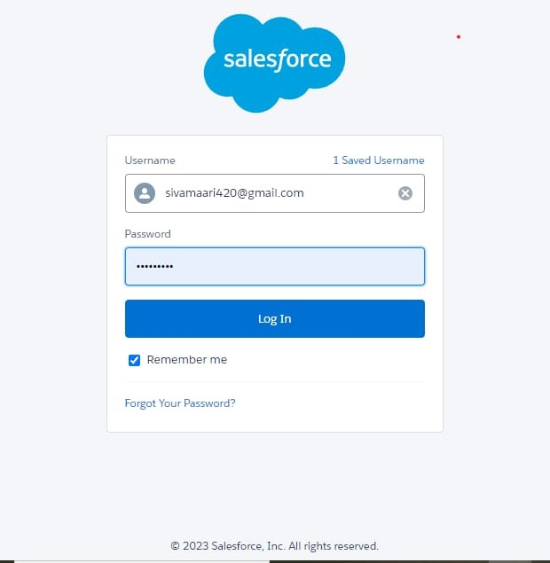

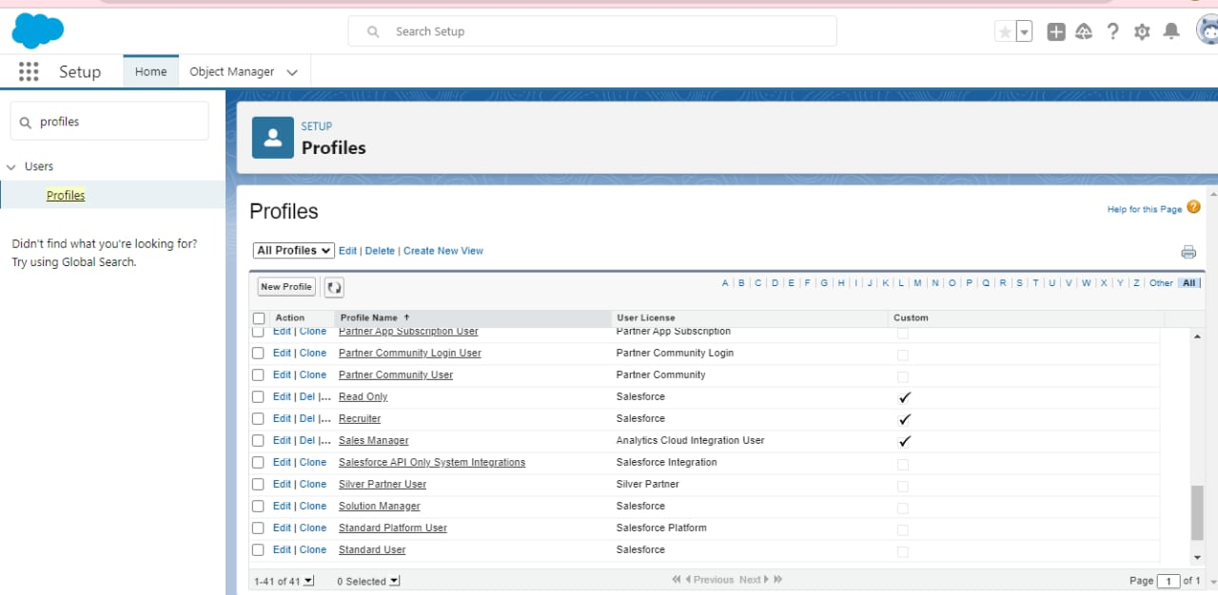

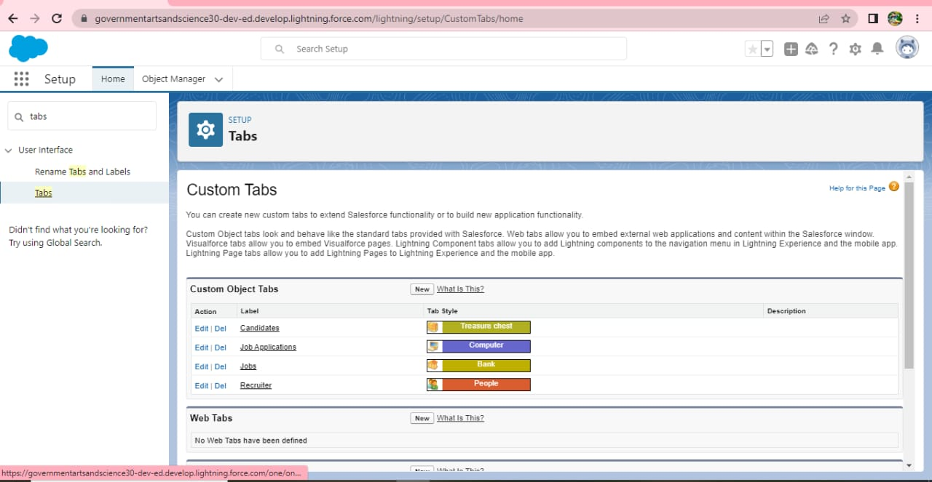

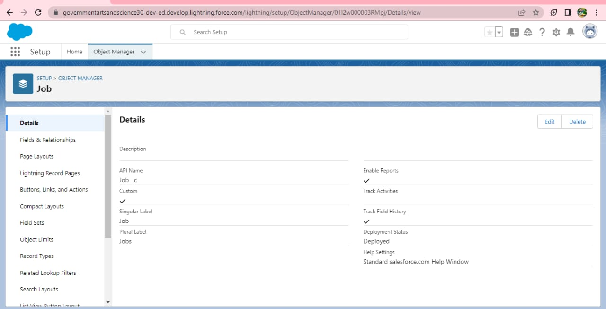

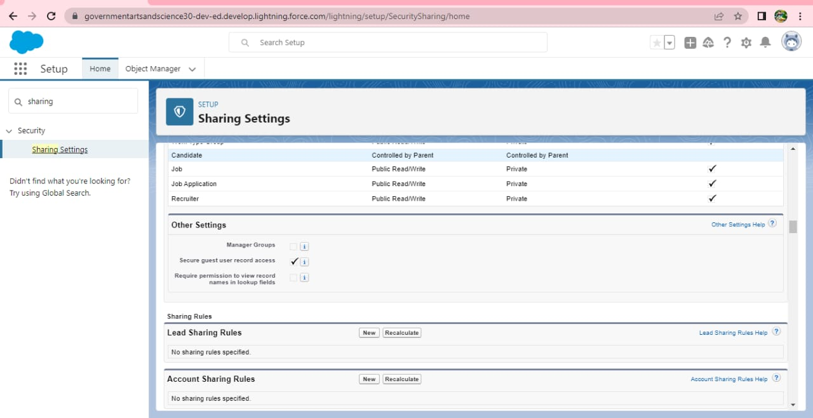

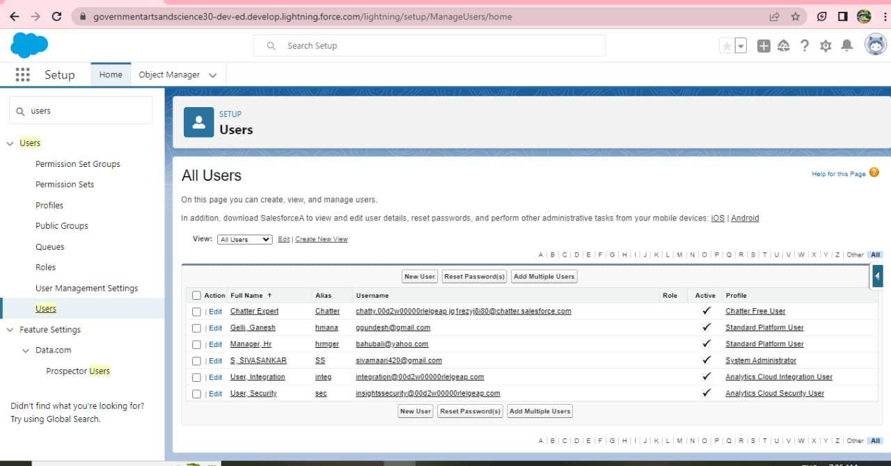

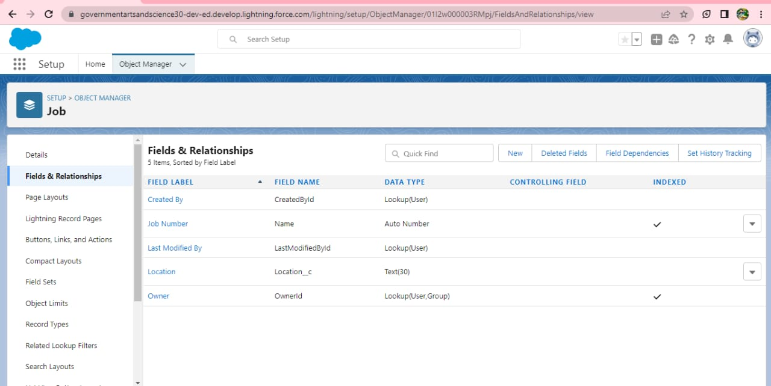

**4 Trailhead Profile Public URL**

**Team Lead -** [**https://trailblazer.me/id/mayak153**](https://trailblazer.me/id/mayak153)

**Team Member 1** - https://trailblazer.me/id/smaari420

Team Member 2 - [**https://trailblazer.me/id/udhar15**](https://trailblazer.me/id/udhar15)

**Team Member 3 -https://trailblazer.me/id/madap13**

**5 ADVANTAGES & DISADVANTAGES**

**ADVANTAGES:**

**1).Reduces time spent on arming tasks.**

**2).Resume and CV screening and speeds up the recruitment**

**3).Improve the quality of hire.**

**DISADVANTAGE:**

**1).Could filter out good candidates**

**2).Communications can be less personalized**

**6 APPLICATIONS**

**1l.Enhanced candidate experience**

**2l.Greater efficiency in the hiring process.**

**3l.Immediate impact after the hire.**

**7 CONCLUSION**

Applicant Tracking System for recruiters is a very effective hiring solution that most of the successful recruiters utilize.

Because without it, there is a good chance that your process of moving applicants through different stages can be very difficult.

**8 FUTURE SCOPE**

One of the biggest advantages of the applicant tracking system is the automation of the entire recruitment process making the recruiter’s job easier. However, today’s market constantly demands more innovation from the introduced methods. Is the ATS capable of turning into an even more powerful recruiting machine? Here are some forecasts about the future of applicant tracking systems.